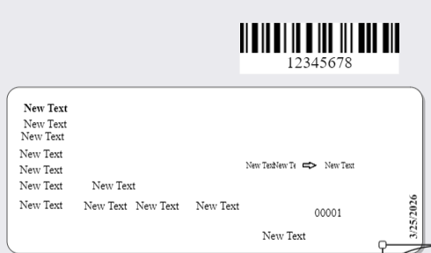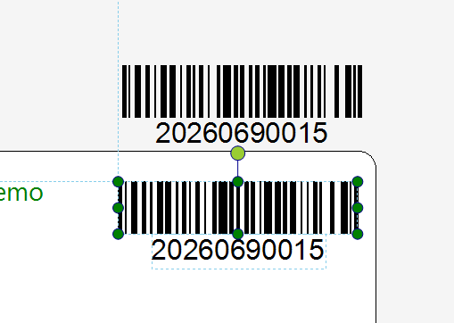
OMG Barcode Wag Label Barcode
- Background Transparency Issue
- The barcode background appears white, but it is expected to be transparent.
- This causes visibility and design inconsistency in documents.
- Text Editing Limitation.
- Editing the barcode text updates only the displayed text.
- The barcode height and structure do not adjust accordingly.
- This results in mismatch between text and barcode appearance.

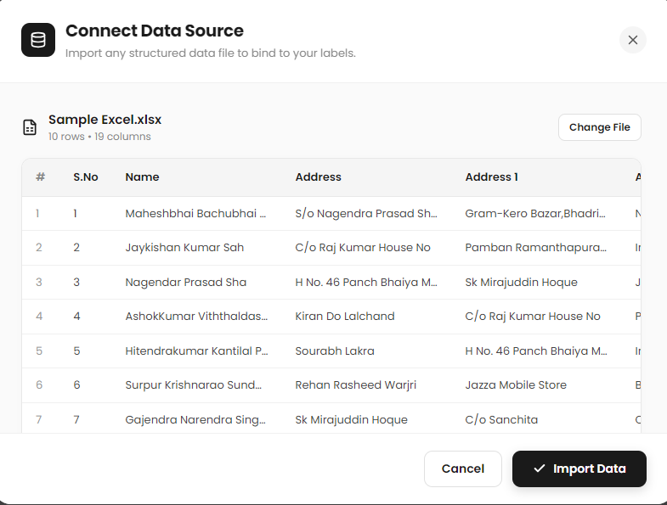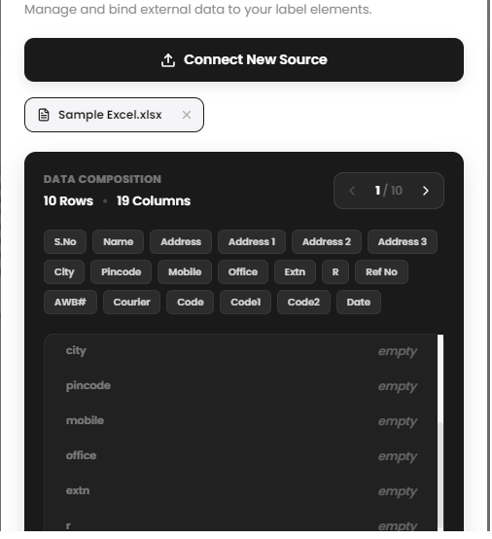
- Data Source Preview (Before Import).
- The preview displayed after adding the data source is correct.
- Data appears as expected and matches the source.
- Issue After Importing Database.
- After clicking Import Database, the preview becomes incorrect.
- The displayed data does not match the original preview.
- We require the same (first) preview format and data accuracy after import.

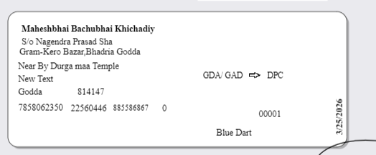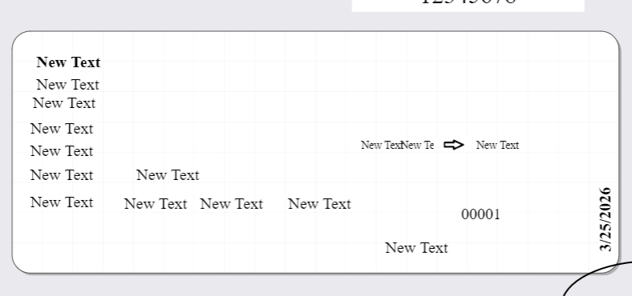
- Data Merge After Save
- Text and barcode are correctly merged with the data source after saving.
- However, this behavior is not consistent when reopening the file.
- Recent File Opening Issue
- When reopening the application and selecting the recent file, data is not retained as expected.
- The file does not restore the previously saved data state.
- Data Loss After Import
- After clicking Import Data Source, all existing data becomes empty.
- Data only appears after manually re-importing or modifying the source file.
- Excel Data Connection Issue
- Once the Excel file is connected, the data should remain stable and unchanged.
- Currently, the data gets altered or reset, which affects reliability.

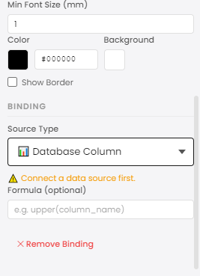
- Empty Data Issue
- Data fields appear empty, resulting in incorrect display.
- Due to missing data, the merged text shows only default or new text values instead of actual data.
- Database Connection Error
- After attempting to connect the database, an error message is displayed.
- The system prompts: “Connect the Data Source First”, even when the connection step has already been performed.
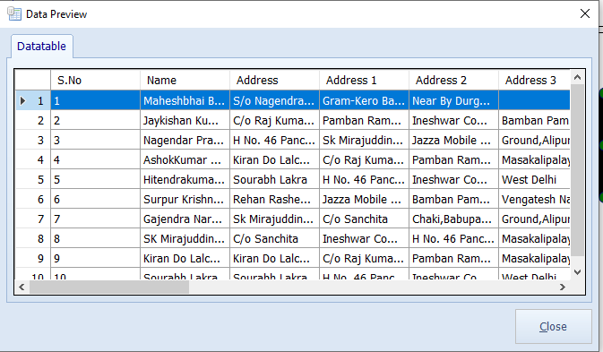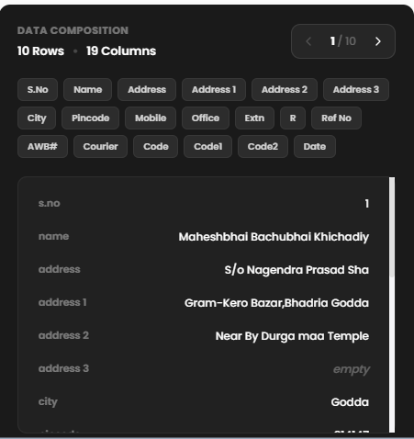
Wag Label Database Preview OMG Data Source Preview
- We Need wag label Data base Preview
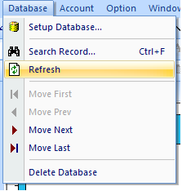

- Excel Update Behavior
- When the customer saves changes in the Excel file, only the modified data/content should be updated.
- The system should not reload or alter the entire Excel structure.
- Refresh Functionality Requirement
- A Refresh option should be available in the application.
- Any updates made in the Excel file should be automatically reflected in the data source preview.

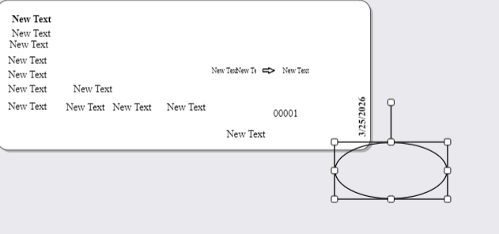
- Sensitivity Issue
- The circle control is too sensitive to adjustments.
- Small movements cause large or inaccurate changes, making it difficult to control.
- User Difficulty
- Users are unable to adjust the circle precisely.
- This impacts usability and slows down the design process.
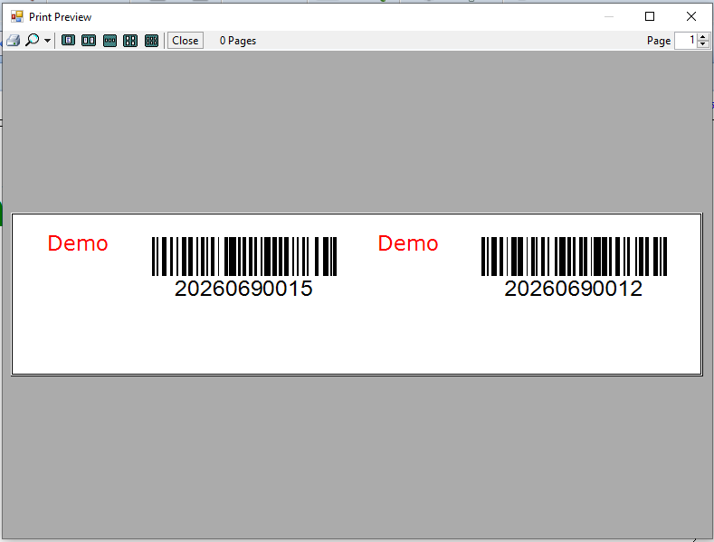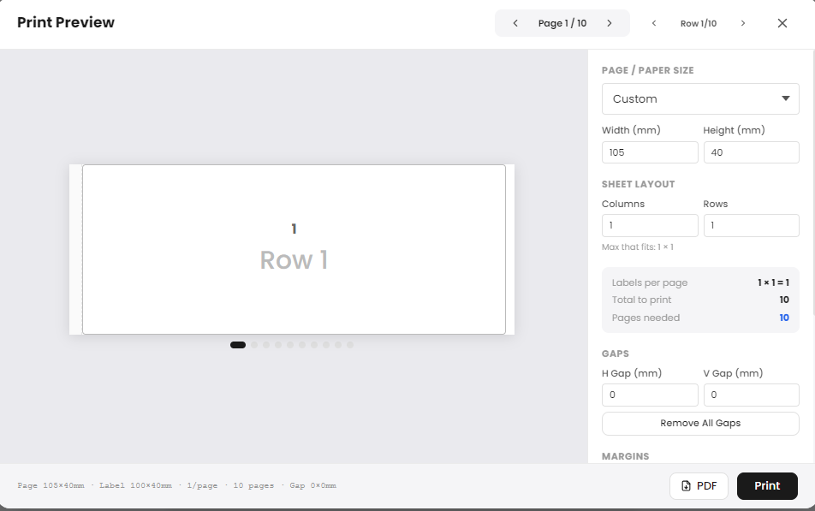
Wag Label Preview OMG Preview
- Empty Label in Print Preview
- When checking the Print Preview, the label appears empty.
- No data or barcode content is displayed.

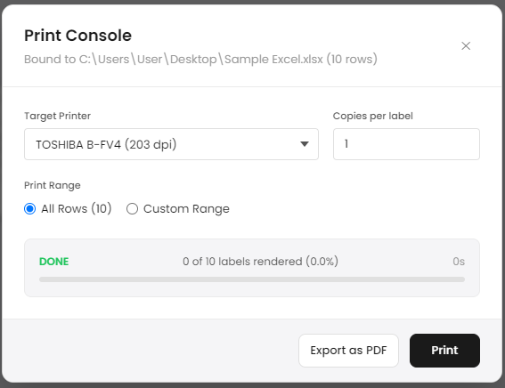
- I sent the print command, but the printer did not receive any data. The data was not sent to the printer.
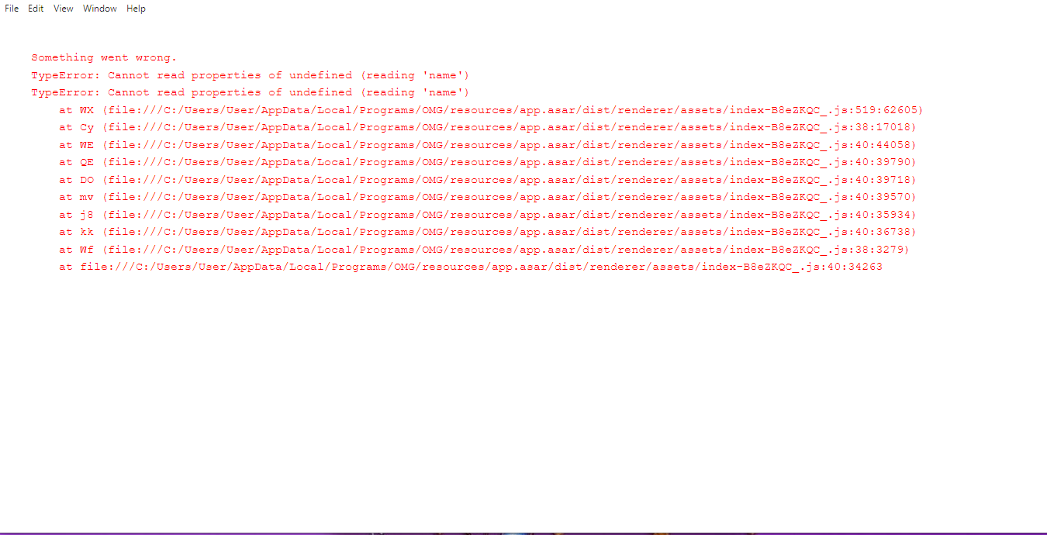
- Sometimes this error appears, but it resolves when I close and reopen the application.

